

**KCV**

Índice

1. Introdução 3

2. LMK 3

2.1. Variant 3

2.2. Keyblock 3

3. Observação 4

4. Release Notes 5

# Introdução

Como calcular o KCV de uma chave de criptografia.

# LMK

## Variant

|  |
| --- |
| Component 01: 45B5 9EF2 BA2A D0F1 D6F4 8FEF AB6E 0279  Component 01 check value: 6042D6  Component 02: 7AF4 0B70 0110 E98C 4568 8583 40E6 B673  Component 02 check value: 03D24A  XOR: 3F419582BB3A397D939C0A6CEB88B40A  Encrypted key: UFF7B 50BE C841 486F 898C 77D5 0B9D 6D76  Key check value: **181AF0**  Key: 3F419582BB3A397D939C0A6CEB88B40A  Algorithm: 3DES ECB  Crypto operation: Encryption  Data: 00000000000000000000000000000000  Padding Method: ISO9797-1 (Padding method 1)  ----------------------------------------  Encrypted data: **181AF0**2459D263B8181AF02459D263B8 |

## Keyblock

|  |
| --- |
| Component 01: 8DD6 B2C2 4930 A8FA 02A9 55FB F4C7 AB54 Component 01 check value: C07292  Component 02: CCF0 DBEB D4A7 B472 0857 4377 3D50 5042 Component 02 check value: A8311D  XOR: 412669299D971C880AFE168CC997FB16  Encrypted key: S10096K0AN00S00019A9F6D994D4B0EBB5F86163958CB3ADF2C1F32DCFB4316B12A203067C40FE870C971C73B659AB6EB  Key check value: **C41941**  CMAC (AES): operation finished **************************************** Key: 412669299D971C880AFE168CC997FB16 Data: 00000000000000000000000000000000 ---------------------------------------- CMAC: **C41941**07C3CCCBF67BE7C1E477B508AC |

# Observação

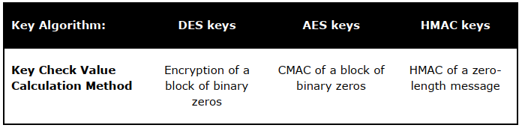

# Release Notes

|  |  |  |
| --- | --- | --- |
| **Autor** | **Descrição** | **Data** |
| Caio Ferreira | Primeira versão | 01/02/2020 |
|  |  |  |